




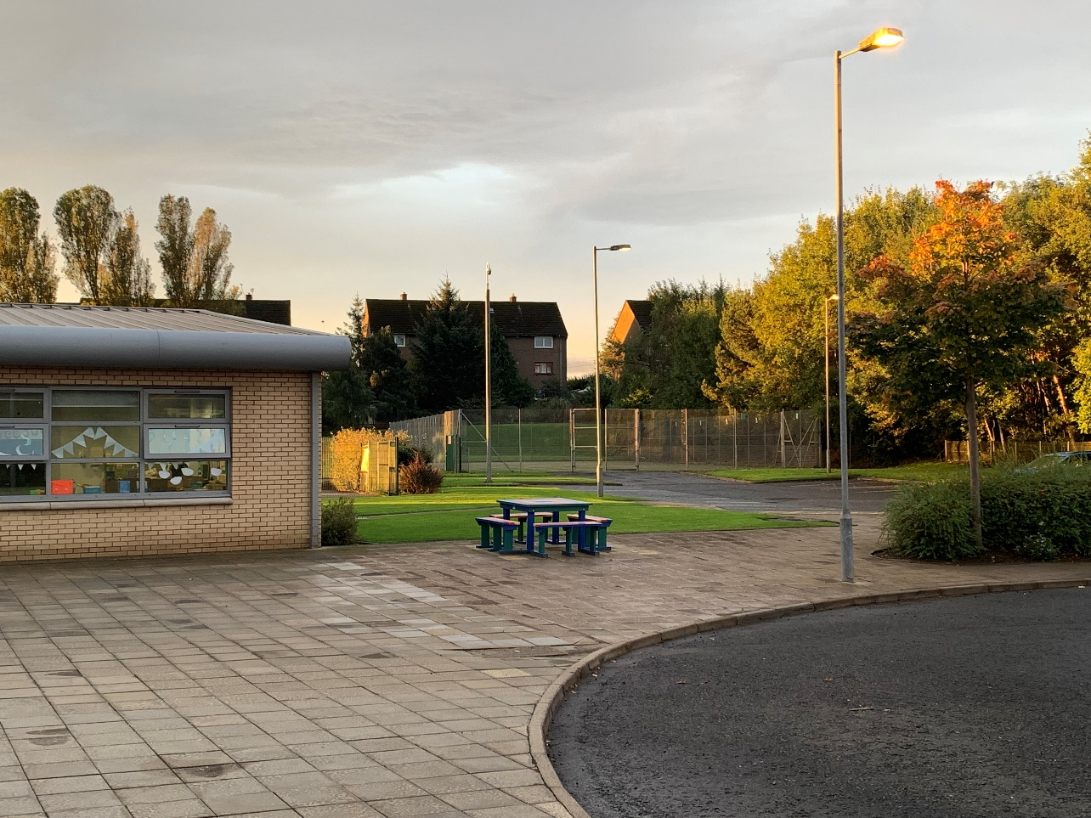




Rowanfield Special School – Raising Attendance = Raising Attainment

Celebrate Success

courage, curiosity, compassion and creativity.
% |  | SCHOOL DAYS MISSED | OUTLOOK FOR YOUR CHILD
100% | Excellent | 0 Days | Gives your child the best chance of success
95% | Good | 9 days  (1 week and 4 days) | Gives your child the best chance of success
90% | Below average | 19 days  (4 weeks and 4 days) | Starts to become harder for your child to progress
85% | Unsatisfactory | 27 days  (5 weeks and 3 days) | SERIOUS IMPLICATIONS  Harder to make and maintain friendships  Becomes difficult to catch up with work  A child with below 85% attendance can be referred to the Education Welfare Service
80% | Unsatisfactory | 36 days  (7 weeks and 3 days)  *HALF A TERM MISSED*
70% | Unacceptable | 57 days  11 weeks and 2 days)  *1 WHOLE TERM MISSED * | VERY SERIOUS IMPLICATIONS  Extremely difficult to catch up with work.  Increased risk of social isolation  Child unlikely to have a positive view of education  Becomes harder to succeed in mainstream education; unlikely to gain qualifications, resulting in a difficult transition to positive destination (employment, further education)  Extremely likely to impact on confidence, self-esteem and mental health  Risk of legal action against parent/carer which may result in prosecution

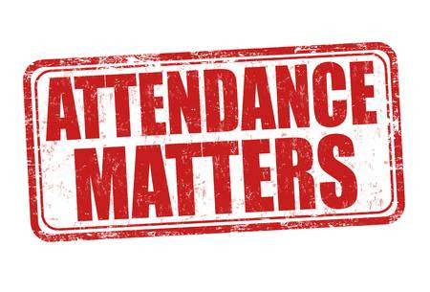

WHY?




