Rowanfield
Special
School
Handbook

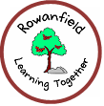

2022 – 2023

A Foreword from the Executive Director of Education, and Children’s Services
Session 2022 - 2023

Dear Parents/Carers,

This brochure contains a range of information about your child’s school which will be of interest to you and your child. It offers an insight into the life and ethos of the school and also offers advice and assistance which you may find helpful in supporting and getting involved in your child’s education.

We are committed to working closely with parents and carers as equal partners in your child's education, in the life of your child's school and in city-wide developments in education.

Parental involvement in the decision-making process and in performance monitoring are an integral part of school life. We look forward to developing that partnership with your support.

Throughout this handbook the term ‘parent’ has the meaning attributed in the Standards in Scotland's Schools Act 2000 and the Scottish Schools (Parental Involvement) Act 2006. This includes grandparents, carer, or anyone else who has parental responsibility for the child.

I am pleased to introduce this brochure for session 2022 - 2023 and hope that it will provide you with the information you need concerning your child’s school.

If you have any queries regarding the contents of the brochure, please contact the Head Teacher of your child’s school in the first instance who will be happy to offer any clarification you may need.

Amanda Hatton

Executive Director – Education and Children’s Services

Education, and Children’s Services Vision

Our vision is for all children and young people in Edinburgh to enjoy their childhood and fulfil their potential.

We believe that children and young people do best when:

- they can live safely and happily within their own families with the right kind of support as needed
- they attend first class, inclusive schools and early years settings which meet their needs

We will do all we can to strengthen support for families, schools, and communities to meet their children's needs.

Our mission is to place children, young people, and families at the heart of our service and provide support when it is needed throughout childhood and the transition to adulthood




In Edinburgh children and young people are at the heart of our vision for the future.

As an inclusive community we work with parents, carers and, where appropriate, partner agencies to support all children and young people.
By working together, we help children and young people to develop understanding about relationships, respect, teamwork, honesty, fairness, patience, and compassion. We do this by offering interesting and relevant learning experiences, by providing our staff with the training and resources they need, and by working with the whole community to accept and care for one another. This isn’t always easy, but we believe it is essential so that our children and young people understand the people they meet and learn how to work together to handle setbacks and difficult situations throughout their lives.
When children and young people experience adverse events or as a response to their additional support need, they let us know by reacting in different ways. This presents difficulties for those around them. By working together, by understanding the cause and working out solutions, we can find a way to solve or deal with a problem. If it takes time to get over a problem we will work with a child, young person, and their family to work out the best way forward. This may involve making adaptations and providing additional support or in exceptional circumstances identifying a change of environment.
We recognise that we all experience difficult times, and that everyone deserves the best possible care and support. In Edinburgh we support children and young people to learn in different ways according to their needs. As children and young people learn to read, write, and count some require more support than others do. This need for support arises for a variety of reasons learning difficulties, challenges with emotional regulation and social communication issues. We must meet the needs of all our students in a fair, compassionate, and proportionate way.
In considering how to support all children and young people reach their full potential it may not always be possible to arrive at a resolution all parties agree. However, we will listen to any parent, young person, child or member of staff and work together to resolve difficulties.
We are committed to do all we can to make Edinburgh an inclusive place to live and learn.
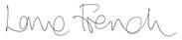
Lorna French
Acting Head of Schools and Lifelong Learning and Chief Education Officer

Welcome from the Head Teacher

Dear Parents and Carers,

Welcome to the Rowanfield School Handbook for session 2022/23 - we are delighted to share information about our school with you.

This handbook offers an introduction to our school and a general overview of the education your child will be getting at school.

To make our handbook easy to use we have divided the information into five different sections: -

Section One Practical Information about the School

Section Two Parental Involvement in the School

Section Three School Curriculum

Section Four Support for Pupils

Section Five School Improvement

If you have any questions or would like any further information on any aspect of this handbook or the education of your child, please do not hesitate to contact the school.

Kind regards,

Rosy Hume
Headteacher

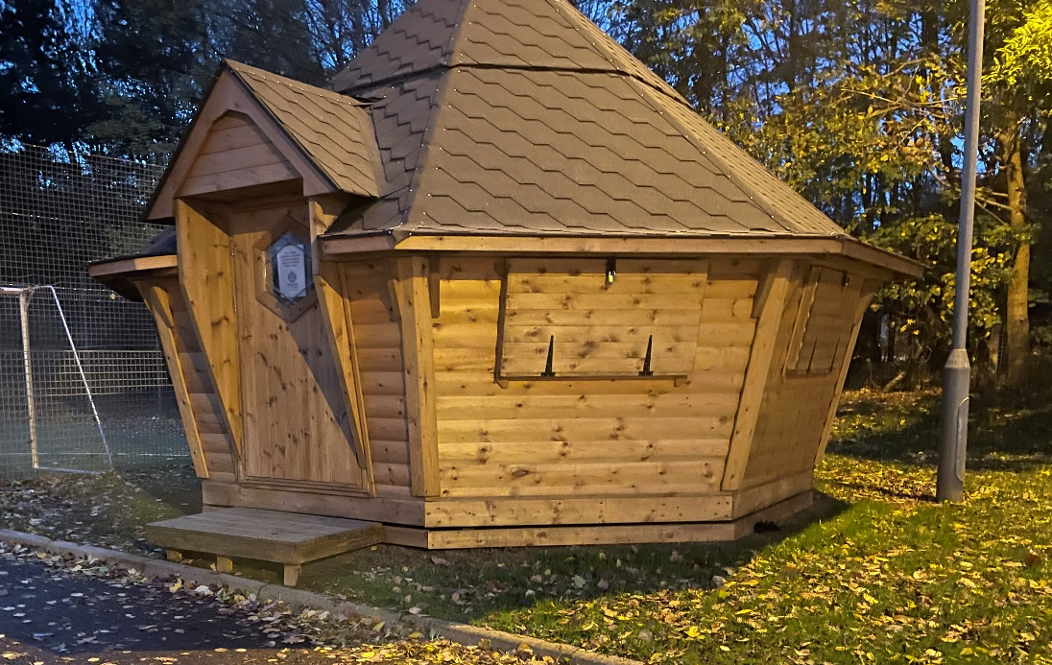

Section One

Practical Information about the School

This section deals with the practical aspects of your child’s attendance at our school. It provides details on such things as:

Communicating with the School

This section provides you with some background information on our school. It tells you how our school day and school year are made up and how to contact the school if, for example, your child is ill.

Contact Details
Head Teacher | Rosy Hume
Depute Head Teacher/s | Sophie Millar
Principal Teacher/s | Sarah Douglas
Business Manager | Sandra Tulloch
Administrator | Karen Hall
Address | 67c Groathill Road North  EDINBURGH  EH4 2SA
Telephone Number | 0131 343 6116
Website | https://rowanfieldschool.com
E-mail Address | admin@rowanfield.edin.sch.uk
About the School
Stages of Education provided for |  | 5-12
Present Roll |  | 46

Organisation of the School Day
 | Mondays – Thursdays |  | Fridays
Start Time | 08:55 |  | 08:55
Morning Break | 10:30 |  | 10:30
Lunch Time | 12:00
Finish Time | 15:10 |  | 12:10

Term dates

Term dates for the coming years can be found at:https://www.edinburgh.gov.uk/schools/term-dates

School Session Dates 2022/23

Staff resume |  | Monday | 15 August * | 2022
Staff only |  | Tuesday | 16 August * | 2022
Pupils resume |  | Wednesday | 17 August | 2022
Autumn Holiday | Schools closed | Monday | 19 September | 2022
All resume |  | Tuesday | 20 September | 2022
Mid-term | All break | Friday | 14 October | 2022
Staff resume |  | Tuesday | 25 October* | 2022
Pupils resume |  | Wednesday | 26 October | 2022
Term ends |  | Tuesday | 20 December | 2022

Staff resume |  | Wednesday | 4 January* | 2023
Pupils resume |  | Thursday | 5 January | 2023
Mid-term | All break | Friday | 10 February | 2023
All resume |  | Monday | 20 February | 2023
Term ends |  | Friday | 31 March | 2023

The Easter break incorporates the following two holidays
Good Friday | Schools closed | Friday | 7 April | 2023
Easter Monday | Schools closed | Monday | 10 April | 2023

All Resume |  | Monday | 17 April | 2023
May Holiday |  | Monday | 1 May | 2023
Staff only |  | Tuesday | 2 May* | 2023
Pupils resume |  | Wednesday | 3 May | 2023
Victoria Day | Schools closed | Monday | 22 May | 2023
All resume |  | Tuesday | 23 May | 2023
Term ends |  | Wednesday | 28 June | 2023

Registration and enrolment

Placement in our school occurs as a result of an application to the multi-agency Education Placement Group (EPG). If a place in our school is granted, the child’s family will have received a letter from City of Edinburgh Council offering them a place. We support transition and enrolment in our school by linking with the child’s family, current school and by attending a transition child planning meeting.

Attendance and absence

It is the responsibility of parents of a child of school age to make sure that their child is educated.

Absence from school is recorded as
- authorised, that is approved by the Education, and Children’s Services department, or as
- unauthorised, that is unexplained by the parent (truancy).

Please let the school know by letter if it is a planned absence (e.g. hospital appointment) or phone by 8.30 a.m. on the day of your child’s unplanned absence (e.g. sickness bug).

You should update the school on each day of your child’s absence. Please phone the school confirming the reason for absence. If there is no explanation from a child’s parents, the absence will be regarded as unauthorised.

Please make every effort to avoid family holidays during term time as this will disrupt your child’s education and reduces learning time.

Headteachers can approve absences up to two school weeks (10 days) from school in certain situations. Any requests for extended absence over two school weeks (10 days) will be referred to the Senior Education Officer, who will decide if it will be recorded as authorised or unauthorised leave.

Please discuss your plans with your child’s Headteacher before booking the holiday. If they cannot give permission before the holiday, it will be recorded as unauthorised absence. They can authorise a holiday if you can prove that work commitments make a family holiday impossible during school holiday times. Normally, your employer will need to provide evidence of your work commitments. Absence approved by the Headteacher on this basis is regarded as authorised absence.

Parents may request that their children be permitted to be absent from school to celebrate recognised religious events. Absence approved on this basis is regarded as authorised absence. Extended leave can also be granted on request for families returning to their country of origin for cultural or care reasons.

A supportive approach is taken to unexplained absence. However, the Education, and Children’s Services department has legal powers to write to, interview or prosecute parents, or refer pupils to the Reporter to the Children’s Panel, if necessary.

School Uniform

Parents are asked to co-operate with the school in encouraging the wearing of the school uniform.

It incorporates a range of popular items of dress, e.g., sweatshirts, T-shirts. Wearing school uniform contributes to a positive school ethos and helps avoid discrimination and reduces peer pressure to wear expensive designer clothing.

School uniform is always available to order from the school office.

A school’s reputation can also be enhanced in the local community by the wearing of school uniform and school security will be improved as it will be easier to identify intruders.

The appropriate clothing and footwear for PE is a T-shirt, shorts and gym shoes with non-marking soles. These are necessary for health and safety reasons and your co-operation is requested to ensure that pupils are equipped to participate in the PE lessons.

Please ensure that all items of clothing are clearly labelled, particularly ties, sweatshirts and PE equipment which are often lost.

Please help us by ensuring that pupils do not bring valuable or expensive items of clothing to school.

In certain circumstances, appropriate clothing will be necessary for school activities for safety reasons, e.g., in games areas, Outdoor Education, swimming; going to the Yard this extends to the wearing of suitable footwear and the wearing of jewellery and earrings. Offensive clothing such as T-shirts or other items painted with obscene language or illustrations are not permitted. Football colours are also inappropriate as they can lead to incidents of rivalry.

If you have any queries regarding the school’s dress code, please contact the school office.

School Meals

Menus offer healthy and tasty meal options while reflecting the Scottish Governments food and drink legal requirements in both primary and secondary settings. Our menus are written to balance pupil choice with the most stringent of school food standards in the UK.
All our menus are nutritionally analysed and new dishes trialled by pupils prior to menu launch
- All our meat is either Quality Meat Scotland or Red Tractor Assured
- All our dairy comes from Scottish Farms
- All eggs used are Free Range
- All fish is MSC certified
- We believe in sourcing food with provenance and aim to increase our spend with Scottish suppliers every year
The catering service supplies meals for pupils by following the special diet policy – more information on menus/ special diets and prices can be found here;
https://www.edinburgh.gov.uk/food-clothing/lunch-menus-schools
All children attending Special Schools are entitled to free school meals.
Clothing Grants

A parent will qualify for a Clothing Grant if they meet any of the following conditions:
- Universal Credit (where your monthly earned income is not more than £610)
- Income Support
- Income-based Job Seeker's Allowance
- Income-based Employment and Support Allowance
- Support under Part VI of the Immigration and Asylum Act 1999
- Child Tax Credit, but not Working Tax Credit, and your income is less than £16,105
- Both Child Tax Credit and Working Tax Credit and an income of up to £6,900
Your child might still get a clothing grant if you're experiencing financial hardship. This could be because:
- your immigration status means you cannot get help from the government
- you're still waiting on your first Universal Credit notice

Clothing Grants are paid direct into a nominated bank account. The payment will show in the bank statement as ‘CEC-EXPEN1’.

Children in all special school settings get Free School Meal but an application should be made so they qualify for both free school meal and a clothing grant.
Each award is valid for one school year. The award provides
- each child with one school meal and milk each day they attend school
- a clothing grant payment of £100 for each child.
We pay one clothing grant per year, per child, into your bank account. Most clothing grants are paid throughout July and August before the new school year begins.
Information on free school meals and clothing grants and how to apply is available on the website: https://www.edinburgh.gov.uk/schoolgrants

Travel to and from School

All pupils are transported to and from school in taxi/minibus provided by the city of Edinburgh Council Corporate Transport Department. The children are supervised by escorts who are responsible for their safety. Parents or their representatives must receive their children from the transport when they are delivered home since the escorts are not permitted to leave other children on the transport unsupervised. Parents are asked to inform transport contractors when children are off school ill and when they are likely to return to school. The contact number for school transport is: 0131 469 2950.

For those that walk to school supervision is parental responsibility, therefore pupils walking to school with parents should not arrive at school until as near to the school start time as possible. Some schools offer Breakfast Clubs which have their own supervision arrangements prior to the start of the school day. During intervals support staff supervise the children. There is always access to the building and toilets, and the children are made aware of this.

School Security

The safety and security of pupils and staff when attending or working in a school is very important to us. Schools use several security measures including visitors’ books, badges and escorts, while visitors are within the school building.

Everybody calling at a school for any reason will be asked to report to the school office. The school staff then can make the necessary arrangements for the visit. We would respectfully ask that parents do not attempt to enter schools through another entrance, unless supervised by a member of staff.

If you wish to speak to a member of staff then please come to the school office where we shall be happy to arrange this for you.

Unexpected Closures

In the event of an emergency, such as Covid, a power cut or severe weather, that prevents schools from opening in the morning or results in an early closure a range of communications channels are used to let parents know.

You may be contacted by phone, email or text.

In addition, announcements will be made on local radio stations and via the Council's corporate Twitter account www.twitter.com/Edinburgh_CC and Facebook page www.facebook.com/edinburghcouncil.
If many schools are affected, or the situation is likely to be prolonged, then the Council's website https://www.edinburgh.gov.uk/schoolclosures will also be used.

Mobile phones

The benefits of mobile phones are recognised. Many young people and their parents regard them as an essential means of communication. Mobile phones can continue to be brought into schools however the following limitations will apply in our school.

Any devices brought into school should be handed in to the office on arrival where, if necessary, they can be charged. They will be returned at the end of the school day.

Complaints, Comments and Suggestions Procedure

We all hope that you will be completely satisfied about your child's education and we encourage feedback on our services from parents and pupils. We are, therefore, interested in feedback of all kinds, whether it be compliments, suggestions, or complaints.

If you want to register a comment of any type about our school you can do this by writing, e-mailing, telephoning, or making an appointment to see someone. All feedback is welcome and keeps us in touch.

If you have a particular complaint about the school, please let us know. It is better that these things are shared openly and resolved fairly, rather than being allowed to damage the relationship between the family and the school. There will be no negative consequences arising from making a complaint and we will deal with the issue as confidentially as possible.

There are some things which you should take note of in relation to making a complaint:
- Please make any complaints initially to the Headteacher. This makes sure that the school knows what is going on and has an opportunity to respond and resolve the issue.
- We will try to respond as quickly as possible, but often issues are complex and we need time to investigate.
- If you are dissatisfied with the service or/and with our response then you will have the right to take the matter further and contact Advice and Complaints Service (Schools and Lifelong Learning) email: cf.complaints@edinburgh.gov.uk or by telephone: 0131 469 3233.

If you remain dissatisfied after the further investigation and reply you can take the matter up with the Scottish Public Services Ombudsman, our reply will include the contact details.

Health and Safety

Within the general policy laid down by The City of Edinburgh Council, the Education and Children’s Services Department has prepared and has continuing development of, safety policy statements for all areas of its responsibility and accordingly manages health and safety and welfare in a way that complies with health and safety statutory and regulatory requirements, and all relevant approved codes of practice and guidance.

School staff are fully instructed in their responsibilities in this respect, and safety regulations apply to all aspects of school life, both on and off the premises.

It is expected that pupils will behave responsibly and comply with all safety requirements.

The support of parents/carers in promoting good practice in health and safety matters is of great importance to the school.

Information about how we manage pupil data in schools/ELC settings

Rowanfield School has a legal responsibility to deliver an effective educational programme to its pupils. In order to do this, we need to collect personal data about our pupils/children and their families so that we can help them learn and keep them safe. The type of personal data we will collect include:

Data about our pupils/children and their families

This will include the name, address, and contact details of the pupil/child and relevant family members. It will also include information about relevant medical conditions, any additional supports which are needed, and their family situation. We need this information to ensure we know our pupils/children and their families, and to ensure we are able to educate them appropriately and keep them safe.

We will also collect personal data relating to personal characteristics, such as ethnic group to enable statistics to be reported. We need this information so the Council can ensure it is delivering education appropriately to all its citizens.

Data about pupils/children at school/within ELC setting

This will include data about progress, assessments, and exam results. It will also include records of attendance, absence, and any exclusions. We need this information to understand how our pupils/children are progressing, and to assess how we can help them to achieve their best.

Data about when and where they go after they leave us

This will include information about their next setting/school, career paths or intended destinations. We need this information to ensure we support our pupils/children in all their transitions and do all that we can to help their future be a success.

There will be times where we also receive information about them from other organisations, such as a pupils’ previous school, the previous local authority where that school or ELC setting was based, NHS Lothian, Police Scotland, Social work, Additional Support Services, and sometimes other organisations or groups connected to a pupil’s education. We use this data similarly to the above: to support our pupils’ learning, monitor and report on their progress, provide appropriate pastoral care; and assess the quality of our services.

When we collect and use personal data within school/ELC setting, and for the reasons detailed above, we will normally be acting in accordance with our public task. Occasionally we are also required to process personal data because the law requires us to do so, or because it is necessary to protect someone’s life.

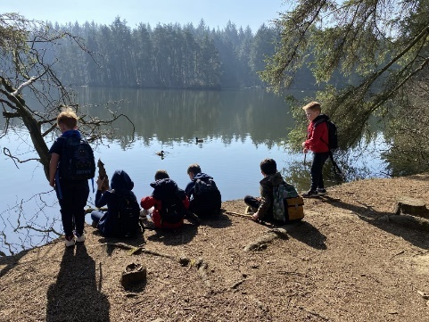
We will also take photographs in school/ELC setting and display them on our walls, and in newsletters and other communications. We do this in order to celebrate and share what we have done, including individual achievements and successes. We consider this use of images to be part of our public task as it helps us build an effective community which supports learning. We will not, however, publish these photographs on social media or in newspapers without permission. Consent for this use will be sought when a pupil/child joins Rowanfield and will be kept on record while they are with us. Consent can be withdrawn at any time, please just let us know.

Sometimes we need to share pupil information with other organisations. We are required, by law, to pass certain information about our pupils to the Scottish Government and the Council. This data is for statistical purposes and will normally be anonymised. It is normally required to enable the Council, and the Government, to understand how education is being delivered and to help them plan for future provision. Further information about what the Scottish Government does with statistical data it receives is provided below.

If a pupil/child moves schools/ELC settings, we have a legal obligation to pass on information to their new school/education authority about their education at Rowanfield.

When we record and use personal data, we will only collect and use what we need. We will keep it securely, and it will only be accessed by those that need to. We will not keep personal data for longer than is necessary and follow the Council’s Record Retention Schedule and archival procedures when records are identified to be of historical value and require to be retained in the Edinburgh City Archives.

For more information on how the Council uses personal data, and to know more about your information rights including who to contact if you have a concern, see the City of Edinburgh’s Privacy Notice.

Sharing personal data to support Wellbeing

In addition to the above, Rowanfield has a legal duty to promote, support and safeguard the wellbeing of children in our care.

Wellbeing concerns can cover a range of issues depending on the needs of the child. Staff are trained to identify when Education, and Children’s Services can be supported and records are kept when it is thought that a child could benefit from help available in the school/ELC setting, community or another professional. You can expect that we will tell you if we are concerned about your child’s wellbeing and talk to you about what supports might help in the circumstances. Supports are optional and you will not be required to take them up.

If it would be helpful to share information with someone else, we will discuss this with you and seek your consent before we share it so that you know what is happening and why. The only time we will not seek consent to share information with another organisation is if we believe that a child may be at risk of harm. In these situations, we have a duty to protect children, which means we do not need consent. On these occasions, we will normally tell you that information is being shared, with whom, and why – unless we believe that doing so may put the child at risk of harm.

We will not give information about our pupils to anyone without your consent unless the law and our policies allow us to do so.
Sharing educational data with the Scottish Government
The following information has been provided by the Scottish Government – Education and Training Division to let you know why they collect statistical information from school and what they do with it:
Education authorities and the Scottish Government collected data about pupils on paper forms for many years. We now work together with schools to transfer data electronically through the ScotXed programme. Thus, the Scottish Government has two functions: acting as a ‘hub’ for supporting data exchange within the education system in Scotland and the analysis of data for statistical purposes within the Scottish Government itself.

What pupil data is collected and transferred?

Data on each pupil is collected by schools, local authorities, and the Scottish Government.

The data collected and transferred covers areas such as date of birth, Scottish Candidate Number (SCN), postcode, registration for free-school meals, whether a pupil is looked after by his/her local authority, additional support needs including disability and English as an Additional Language (EAL), and attendance, absence, and exclusions from school.

The SCN acts as the unique pupil identifier. Pupil names and addresses are not passed to the Scottish Government. Your postcode is the only part of your address that is transferred for statistical purposes, and postcodes are grouped to identify ‘localities’ rather than specific addresses. Data is held securely and no information on individual pupils can or would be published by the Scottish Government.

Providing national identity and ethnic background data is entirely voluntary. You can choose the ‘not disclosed’ option if you do not want to provide this data. However, we hope that the explanations contained in this message and on the ScotXed website will help you understand the importance of providing the data.

Why do we need your data?

In order to make the best decisions about how to improve our education service, the Scottish Government, education authorities and other partners such as the Scottish Qualifications Authority and Skills Development Scotland need accurate, up-to-date data about our pupils. We are keen to help all our pupils do well in all aspects of school life and achieve better examination results. Accurate and up-to-date data allows us to:

- plan and deliver better policies for the benefit of all pupils
- plan and deliver better policies for the benefit of specific groups of pupils
- better understand some of the factors which influence pupil attainment and achievement
- share good practice
- target resources better.

Your data protection rights

The collection, transfer, processing and sharing of ScotXed data is done in accordance with the Data Protection Act (2018). We also comply with the National Statistics Code of Practice requirements and other legislation related to safeguarding the confidentiality of data. The Data Protection Act gives you the right to know how we will use your data. This message can give only a brief description of how we use data. Fuller details of the use of pupil data can be found on the ScotXed website (www.scotxed.net).

The Scottish Government works with a range of partners including Education Scotland and the SQA. On occasion, we will make individual data available to partners and also academic institutions to carry out research and statistical analysis. In addition, we will provide our partners with information they need in order to fulfil their official responsibilities. Any sharing of data will be done under the strict control of the Scottish Government, which will ensure that no individual level data will be made public as a result of the data sharing and that these data will not be used to take any actions in respect of an individual. Decisions on the sharing of data will be taken in consultation with colleagues within and outwith the Scottish Government.

Concerns

If you have any concerns about the ScotXed data collections you can email the Senior Statistician, scotxed@scotland.gsi.gov.uk or write to The ScotXed Support Office, Area 1B, Victoria Quay, Leith, EH6 6QQ. Alternative versions of this page are available, on request from the ScotXed Support Office, in other languages, audio tape, braille and large print.

School Nursing Team

The School Nursing team is made up of the
- School Nurse (Specialist Qualified 3rd part Nursing and Midwifery Council (NMC) registrant – now masters level 11 post graduate degree)
- Community Staff Nurses (Registered Nurse on Part 1 of NMC – undergraduate degree)
- Community Health Assistants (not a nurse, may have SVQ qualifications in care related field)

Services provided
Universal Services for All School Age Children:
Child Health Surveillance Programme
- P1 eye tests by Health Assistant - (only for those who did not receive this preschool in nursery)
- Growth Measurements by Health Assistant– currently at Primary 1 and Parent health Questionnaire (this may change in the future dependant on Scottish Government obesity strategy and the Health Visitor assessment at 4-5 years preschool)
- Primary 7 health questionnaire - growth measurement may be added in the future linked to Scottish Government obesity prevention work
- Drop-in Services - a drop in health zone for High School Pupils (either in school or community facility) who are seeking advice or support on sexual health and health related issues

Education of Staff and Pupils
- Staff training – CPD in-service days on health actions plans, anaphylaxis etc – will usually be delivered by the staff nurse
- Healthcare Plans for pupils - education staff will be supported by staff nurses on the planning and education

Healthcare Needs of Children with Moderate to Complex Physical Nursing Needs:
- For children in Complex Needs Schools, nursing care needs will be delivered by the nursing team who are based in these designated schools

School Nurse Services for Children/Young People with Increased Needs:
10 key areas specialist school nurses will focus on:
- Emotional Health and Wellbeing
- Substance Misuse
- Child Protection
- Domestic Abuse
- Looked After Children
- Homelessness
- Youth Justice
- Young Carers
- Sexual Health
- Transitions

How to Refer
Children can be referred to the School Nurse by their school or their GP or other health care professional. Children and young people can also self-refer. They can do this by discussing this at drop ins or asking their teacher/ guidance teacher to refer them. Parents can refer by discussing with their GP or child’s teacher/ guidance teacher.

Further information
Our NHS Lothian School Nursing Service web pages:
https://services.nhslothian.scot/SchoolNursing

Who Does What?
- GP – all regular family health care
- CAMHS – Child and Adolescent Mental Health – Specialist service
- Hospital Paediatric – medical/surgical and other specialist services
- Community Paediatrician – doctors in community child health
- CCN Team – Community Children’s Nurses - specialist paediatric trained nurses
- AHPs – Allied Health Professionals - speech and language therapy, physiotherapy, occupational therapy, dietetics, orthoptics – referral based service
- CVT – Community Vaccination Team - nurses who deliver vaccination services to all age groups
- Learning Disability Services – where there is LD diagnosis
- Oral Health – Dental – prevention and treatment service
- LAC – Looked After Children - nurses who work only with looked after children. When notified by Social Work that a child has become looked after, the LAC nurses will undertake a health assessment. They may refer to school nursing for ongoing reviews and wider support.

Medicine Administration

Staff can administer your child’s medication if necessary. A form will be sent home for you to fill in with the details of medication, dosage, and time to be administered.
If medication changes, then a new form should be completed each time.

Head Lice
Head lice are spread through head to head contact at home, while playing or in school. Regular wet combing of your child’s hair using a head lice detection comb is the best way to catch this possible problem at an early stage. The only way to be sure that your child has head lice is to find a live louse. If you find live lice, get the correct lotion from your doctor, health visitor or pharmacist. Shampoos and other treatments are not effective. One treatment is two applications of the treatment lotion, seven days apart. If this is not followed then re-infection is likely. Advise family members and close friends that your child has head lice and that they should check their own hair. Only treat if live lice are found. Don’t be shy about advising others of this possible problem because you would likely tell family and friends about other infections which might affect them. Regular wet combing of your child’s hair with the head lice detector comb is the best protection as it allows you to detect the condition and treat it speedily.

Use of social media

Rowanfield understands the benefits of using social media; however if misused, our school community can be negatively affected, such as by damaging the school’s reputation. We advise parents, and carers to conduct themselves on social media using the following three commons approach to online behaviour:
- Common courtesy
- Common decency
- Common sense

Parental Requests for class lists

Information about your child is held securely and appropriate safeguards are in place. Due to these safeguards, we are unable to provide parents and carers with the list of names your child is classmates.

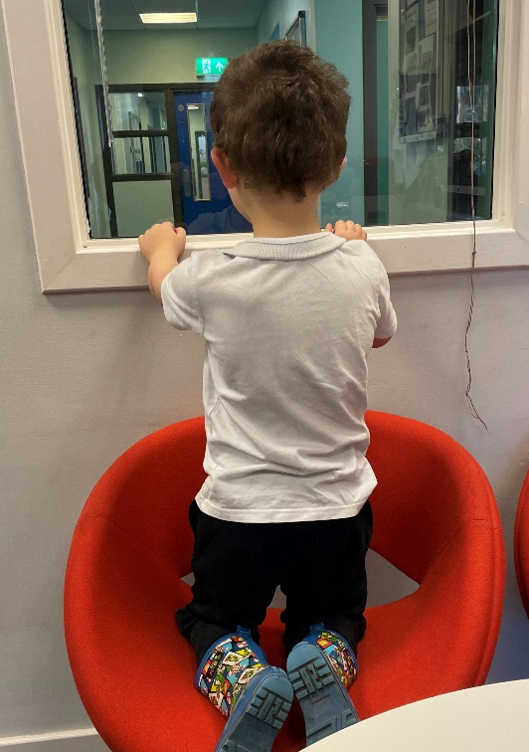
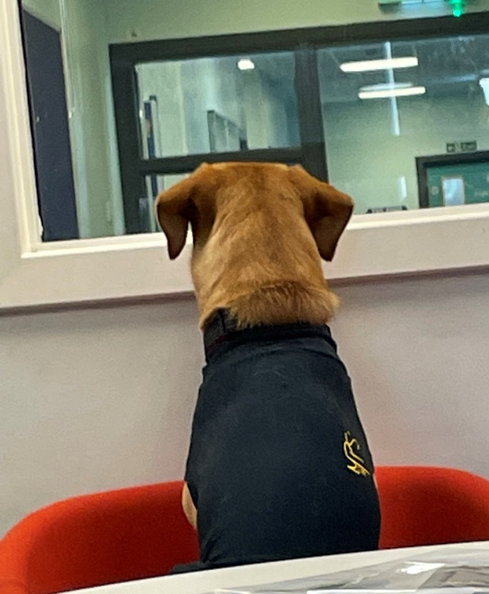

Section Two

Parental Involvement in the School

Parental involvement is very important as we know children and young people do better on a wide range of measures. These positive effects include:
- Better behaviour
- More confidence and greater self-esteem
- Higher attendance rates
- A lower risk of exclusion
- More enthusiasm about learning
- Better results.

This section contains information about our Learning Together Framework and how parents and carers can get involved in their child’s learning.
You can also find out more about the ethos of our school, what our values are and our aspirations for our pupils including how we celebrate pupil success, and links we have with partner organisations and the wider local, national, and international community.
Lastly, it includes information on City of Edinburgh Council structures to support the voice of parents and carers. This includes your Parent Council and Parent Teacher Association/Parent Association, how to contact them and how parents and carers can get involved in the life and work of the school.
Connect https://www.facebook.com/groups/connectingparentgroups is the national organisation for Parent Teacher Associations and Parent Associations in Scotland, Parent Councils can join too, and it runs an independent helpline service for all parents.
The National Parent Forum of Scotland https://www.npfs.org.uk has been set up to give Parent Councils and parents an opportunity to discuss and raise educational issues of mutual interest or concerns at a national level.

Equality

Rowanfield is committed to improving the quality of life for those who face inequality, harassment, discrimination, and prejudice and to harness the talent and celebrate the difference of all who live in the city. This commitment is set out in the Equality, Diversity and Rights Framework which can be viewed on the council’s website. As a school, we are committed to fulfilling our obligation of equity and excellence for all learners, with particular reference to protected characteristics under the Equality Act 2010 (race, gender, disability, sexual orientation, religion/belief, age, marriage or civil partnership, transgender status, or pregnancy/maternity) and other factors such as poverty.

Children’s Rights

The rights of children and young people are at the heart of our code to practice. They are laid out in the United Nations Convention on the Rights of the Child (UNCRC). The UNCRC ensures that children and young people grow up healthy and safe and that their views are taken into considerations in decisions that affect them.
Ethos

At Rowanfield we believe our job is about helping everyone, pupil, parents/carers, and staff to discover their strengths & passions so they can experience success. This in turn builds their confidence to try new things, harder things and to know failing is not fatal because they can remember and revisit the success, they have previously experienced.

2022/23 - Remind, model, and develop together to make a difference in the life of
a child.

Encourage, inspire, and support each other. Build each other up and cheer each other on to
succeed – It is the #TEAM that makes Rowanfield special - the power of WE!

Start small – being a teacher at Rowanfield is about the goal not the role, celebrate the small
things, they will get bigger.

Term starts with developing our school and classroom culture/climate using 3 words –
Ready/Respectful & Safe

SAFE
• Establish relentless routines, expectations, and procedures – Revisit the Rowanfield Way
• Model the behaviour you want to see, connection over correction

RESPECTFUL
• Relationship’s 1st – time, freedom & support to build positive relationships between.
staff & pupils – pupils and pupils – staff & staff
• Create a sense of belonging – everyone is welcome, everyone is wanted every day

READY to learn – the key to success
• Identify and acknowledge strengths & passions – this is the foundation for our learning
• Celebrate success
• Model encouragement and support
• Promote play and outdoor learning

“Learning/school should be fun”
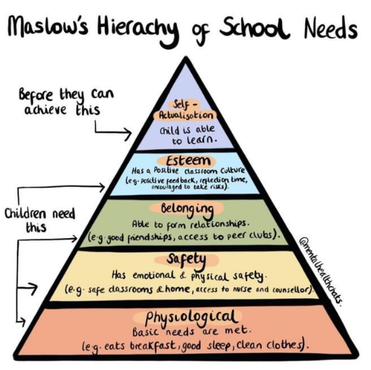
Values

We are committed to supporting the development of the whole pupil and as a result, wish to encourage their development in spiritual, moral, social, and cultural terms. At Rowanfield our values are courage, curiosity, compassion, and creativity.

These key human aspects of learning are supported through the following arrangements by:-
- Creating a school ethos which, in every way possible, gives value to these aspects of development, especially by providing an overall atmosphere that is both caring and challenging and which provides opportunities for the development of personal responsibility.
- Promoting social and moral learning through the way in which disciplinary issues are handled.
- Ensuring that staff and adults within the school provide positive models for pupils.
- Arranging regular gatherings of the school as a community and using such occasions to encourage and reinforce the values on which the school is based.
- Enriching the curriculum in all appropriate areas with an emphasis on spiritual, moral, social, and cultural development.
- Providing opportunities within the curriculum to advance personal and social development.
- Providing a programme of religious education in which consideration will be given to responses to basic questions relating to the meaning, value, and purpose of human life.
- Providing a programme of moral education.
- Taking every appropriate opportunity to acknowledge, value and appreciate the various cultures and heritage of the pupils and to encourage them to appreciate and value the cultures and heritage of others.

Promoting Positive Relationships

SEBN
Social, emotional, and behavioural needs are a type of additional support needs in which children/young people have severe difficulties in managing their emotions and behaviour. They often show inappropriate responses and feelings to situations.
This can mean that they have trouble in building and maintaining relationships with peers and adults; they can also struggle to engage with learning and to cope in mainstream education. Children with SEBN will often feel anxious, scared, and misunderstood.
The needs of young people at Rowanfield are complex. We believe there is no ‘one size fits all’ approach to behaviour management but know that building positive relationships and working alongside young people to build self-esteem are a key part of our everyday practice.

At Rowanfield, four core values underpin our decisions, planning and actions
- Courage
- Curiosity
- Compassion
- Creativity

We believe that
- Children who are courageous are most likely to achieve their aspirations
- Children who are curious will question the world around them
- Children who are compassionate can encourage others to be better
- Children who are creative will be able to solve the problems of the future

To enable children to achieve these qualities school staff aspire too
- Nurture children as individuals and help them recognise what they have to offer as members of society
- Motivate and inspire children to achieve
- Develop children’s interests, passions and/or talents
- Create positive and memorable learning experiences.

When we create this, Children will feel
- That they have something to offer that is valued
- Curious & excited about learning
- Confident to ask questions and have a desire to explore
- Inspired to share their learning.

Learning throughout the school will be
- Dynamic
- Focused
- Active
- Varied
- Promote independent learning through the use of play, outdoor adventure, first-hand learning, exploration, and discovery.
Routines
Routines are very important to children with learning and communication difficulties. Routine makes a sometimes confusing world a little bit more predictable and support the development of communication.
Routine can mean what is happening on a particular day of the week, the way we start and end the day or the timetable we follow. Routines also mean consistent expectations and consistent communication.

There are a number of key elements that we use to build a whole school ethos for promoting positive behaviour at Rowanfield we call this the Rowanfield Way:
Listen – trauma informed
Keep calm – wait, scripts, build self-esteem, provide choices
Be consistent – routine, boundaries, transition
Trauma Informed – kindness, empathy, boundaries, routine, and a predictable schedule. Without these you have chaos which is one of the results of trauma

We understand that everyone learns best when they feel good about themselves. Punishments can make children feel bad about themselves. This can hinder their ability to engage in their learning, including their behaviour. Positive approaches to support behaviour focusses on relationships, skills building, restoration and when appropriate logical or natural consequences appropriate to the child, rather than the implementation of punishments.
We explore and establish “what’s happened” with children. To do this we listen to their response whether that is given verbally or expressed non-verbally and act appropriately. Once the reason and purpose for the child’s behaviour is known we explore how we can develop appropriate support or adaptations to address the issue by promoting well-being, offering coping strategies and agreeing constructive solutions.
We also want to engage directly with parents to foster and develop our positive ethos. To work together to maintain and support shared learning community values and excellent home/school communication. We want to work together to address, prevent and resolve any difficulties should they arise and to build on our strengths together.
We have a small number of easily remembered rules / values which everyone in our learning community knows.
These are summarised in four words: courage, curiosity, compassion, and creativity.
These form the basis of our conversations in relation to behavioural expectations. It is helpful if parents can also discuss these values with their children if there has been an incident in school. The purpose of these conversations is to find solutions and develop skills that will prevent problems in the future.
We use de-escalation techniques, and some staff are CALM trained. CALM interventions are carefully planned and managed with the consent of parents. (Please see our CALM and Safe Space Policy for further information.)

Preventing and Responding to Bullying and Prejudice Behaviour Among Children and Young People

City of Edinburgh Council updated their anti-bullying guidance in session 2020-21.
As an authority, we are committed to equalities and the wellbeing and protection of children and young people from bullying and prejudice. We work to prevent bullying and prejudicial behaviours and attitudes, and to develop positive relationships with all members of our school communities and wider partners. This work is part of our approach to Getting it Right for Every Child, creating communities that allow children to be Safe, Healthy, Active, Nurtured, Achieving, Respected, Responsible, and Included.
Pupil-led equalities groups, which reflect the diversity of the school community, are working to ensure that all children have access to support, are listened to and are involved in the decisions that will continue to make their school a place which feels safe, happy, and nurturing.
As a school, we are committed to equalities and the wellbeing and protection children and young people from bullying and prejudice. Our school procedure is informed by the overarching ‘Preventing and Responding to Bullying amongst Children and Young People’ procedure. We recognise that policy and procedures alone will not address the prevention of bullying; through our core practices (Relationships, Rights Respecting, Resilience, Restorative) we aim to build positive relationships and a culture and ethos which ensure respect, equality, and inclusion. We promote an actively anti-bullying and anti-prejudice culture in our school through preventative, pro-active and responsive approaches.

Bullying and prejudice-based behaviours are not tolerated. The school will put in place appropriate support for all children and young people involved in a bullying or prejudice-based incident. We will support children who display bullying or prejudiced behaviour to identify the feelings and views that have caused them to act in this way. We will challenge these views and support children, through education and learning, to develop alternative ways of behaving. Working together with parents is an essential part of our approach to preventing and responding to bullying. When bullying or prejudice happen it is important that all parents involved work with the school to resolve the problems in the best interests of their child.

Learning Together Framework
All parents and carers are welcomed and encouraged to:
- be involved with their child’s education and learning
- be active participants in the life of the school; and
- express their views on school education generally and work in partnership with their children's schools.

Parental Involvement
‘Parental involvement is about supporting pupils and their learning. It is about parents and teachers working together in partnership to help children become more confident learners.
Parental Involvement Act, 2006
Getting involved in the life and work of your child’s school can include:
- Establishing and reviewing the Vision, aims, rationale of setting/school
- Improvement planning
- Decision-making on education matters affecting child’s learning
- Developing/reviewing policies
- Organising events for families
- Using parents’ skills to enhance/enrich the curriculum
- Short life working groups
- Volunteering
- Developing the young workforce
- Parent Council/Parent Teacher Association
- Parental representation at school, local authority, and national levels

Parental Engagement
Parental engagement can be considered as active involvement in learning.
Parental engagement represents a greater ‘commitment, ownership of action’ than parental involvement within educational settings such as early learning and childcare or schools.
Goodall and Montgomery, 2014
Your child’s school will actively involve you in their child’s learning. This can include
- discussions between parents/practitioners and children
- Focusing on how families can build on what they already do to help child’s learning and to provide a supportive learning environment at home
- Providing clear and regular communication from school to home
- Making good use of information technology and the school website

Family Learning
Family learning is a powerful method of engagement and learning which can foster positive attitudes towards life-long learning, promote socio-economic resilience and challenge educational disadvantage.
Family Learning Network, 2016
Family Learning encourages family members to learn together as and within a family, with a focus on intergenerational learning.
Family learning activities can also be specifically designed to enable parents to learn how to support their children’s learning.

Learning at Home
Learning at home recognises the vital role that parents, family members, peers and practitioners play in children’s learning and development.
Review of Learning at Home 2018
The learning which happens in the home, outdoors and/or in the community, including organised or active learning opportunities
Everyday activities that families already do can be learning at home. These can include
- play
- leisure activities
- fun events
- sports
- trips
- cultural or volunteering experiences
- school related activities such as homework, reading and sharing books.
At Rowanfield we continue to welcome parents into our school as we believe communication is key to build strong relationships, teachers’ text and phone on a regular basis giving updates on learning and achievements. Each term we email newsletters and learning leaflets.
We welcome parents to our child planning meetings that take place at least twice a year in person. We aim to be as flexible as possible in the way we hold meetings with parents and carers. Whenever possible we like to meet face to face however, we know that a phone call or an online meeting can sometimes suit best. Close links with families are vital to ensure we have appropriate targets for each child in place and to ensure continuity between home and school.
Throughout the year we have open afternoons to showcase children’s learning and social events which parents are invited to. Parents and carers also have the opportunity to join sports day, our Christmas and summer fayres.
Families and prospective families are welcome to come and look around the school to find out about the strategies and approaches we use to engage our learners.

Parental Consultation/Reporting to Parents Throughout the Year

Our teachers communicate on regular basis via text message and phone at least once every two weeks. We hold Child Planning Meetings every six months, where the parents are invited in to discuss their child’s progress and that we are all meeting their needs.

Parent Forum and Parent Councils
All parents/carers are automatically members of the Parent Forum at their child’s school. As a member of the Parent Forum, you can expect to –
- receive information about the school and its activities.
- be asked your opinion by the parent council on issues relating to the school and the education it provides.
- work in partnership with staff; and
- enjoy taking part in the life of the school in whatever way possible.

The Parent Forum decides how their representatives on the Parent Council are chosen and how your Parent Council operates. It is important to us that our Parent Council represents the rich diversity of our school community. We warmly invite all parents and carers to volunteer or put themselves forward as representatives on the Parent Council.
The main aims of the Parent Council are:
- To support the school in its work with pupils
- To represent the views of parents and carers
- To promote contact between the school, parents, pupils, providers of nursery education and the community
- To report to the Parent Forum
- To be involved in the appointment of senior promoted staff.
- To raise funds for the school for the benefit of pupils (in some schools the PSA/PTA/PA fulfils this role).

We are currently looking for volunteers to start the parent council/forum at Rowanfield. Please get in touch if you are interested.
For more information on parental involvement or to find out about parents as partners in their children’s learning, please contact the school or visit the Parentzone website at www.parentzonescotland.gov.uk.

Locality groups and the citywide Special Schools Group
Locality groups and the citywide Special Schools Group enables Parent Councils members to get together to discuss common issues and have their views on local and citywide issues heard.
The above groups meet four times a year. There are four locality groups: northwest, northeast, southwest and southeast. There is also one citywide special schools group.

The Consultative Committee with Parents
The Consultative Committee with Parents (CCwP) is a forum that gives parents and carers the chance to discuss citywide and national issues with members of our staff and other groups.
The CCwP meets four times a year. Parent members are chosen at the meetings of the locality groups and citywide special schools group. One parent from the CCwP is put forward to take part in the Education Children Families Committee. This post lasts up to four years.
Education Children’s and Families Committee
The committee has one parent representative who speaks on the behalf of parents, taking their views from their work in a school, locality group and the Consultative Committee with Parents (CCwP).

Who to ask?
All questions/ requests for information can be sent to
parental.engagement@edinburgh.gov.uk
Your email will be forwarded onto the right person/department to provide the answer/support you need.
Pupil Voice Groups
At Rowanfield we have a strong belief in gathering pupil views. We have three Houses - Pop, Whizz and Bang, each House elects House Captains from Primary 7 who meet regularly with the Senior Leadership Team to plan for School Improvement and bring about positive change for our school. Learner voice and learner choice is very important to us and we work hard to ensure all learners are involved and included.
Therapy Dogs

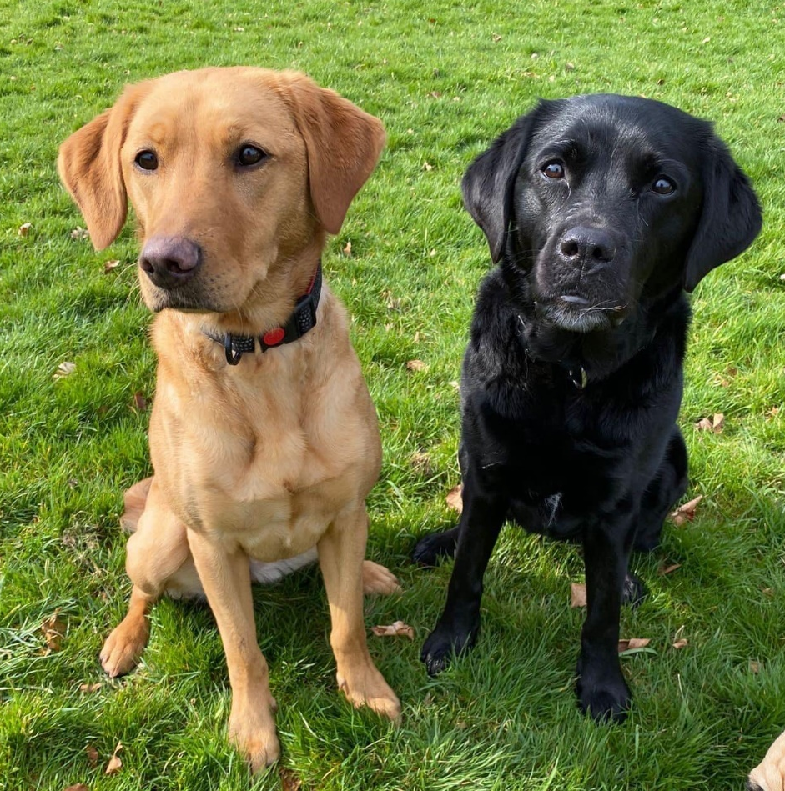

Tango & Pepsi are regular visitors to the school and are well loved members of our school community. A risk assessment is available from the school office.
If you are visiting the school and have any questions, please do not hesitate to contact us. If there is a dog in school they will be out for a walk with pupils or in the HT’s office.

Section Three

School Curriculum

This section describes how the curriculum is planned and delivered in our school including the range of subjects and subject areas your child will be learning. It also includes information on how pupils develop skills for learning, life, and work, including literacy, numeracy and health and wellbeing in and out of the classroom.

As well as giving you information about the statutory curriculum requirements we have included details on sports and outdoor activities available to pupils and the range of facilities available within the school.

Details of how parents will be informed about sensitive aspects of learning e.g., relationships, sexual health, parenthood, and drugs awareness are included as well as information about religious instruction and observance and arrangements for parents who wish to exercise their right to withdraw their child.

Edinburgh Learns for Life –A Vision for Education





Our Vision
The Edinburgh Learns for Life vision is to create a fairer, healthier, greener future for everyone. We will work together to ensure that high quality learning takes place in schools and in the wider communities where young people live, learn and work. All our young people will be supported to make progress in their learning, pursue their interests and passions, without being limited by barriers. We will provide inclusive and equitable learning opportunities for everyone. Learners will be provided with opportunities to lead, and shape, their own learning where a wide range of pathways are valued equally. Through working together, we will form relationships, and connections, which support positive health and wellbeing and reduce poverty.
Our pupils have complex, long term additional support needs (ASN) which are primarily associated with a learning disability, autism spectrum disorder, (ASD) attention deficit hyperactivity disorder, (ADHD) foetal alcohol spectrum disorder (FASD) trauma and attachment. These additional support needs impact on their ability to develop skills for learning, life and work. We want our pupils to be as independent and included in society as they can be and our curriculum, teaching approaches and environment are adapted to enable this.
We build a consultative approach with parents, partner services and the local community and we value this as it enables us to provide a curriculum that is meaningful, breaks down the barriers to learning and continue to develop our inclusive society.
We want our pupils to feel a sense of belonging, build their confidence/self-esteem and continue to experience achievement and success now and in their future and enjoy these successes. Our curriculum has a clear rationale based on our school values; courage, curiosity, compassion and creativity.

Curriculum for Excellence: Bringing learning to life and life to learning

Curriculum for Excellence is the curriculum across Scotland for all 3-18 year olds – wherever they learn. It aims to raise standards; preparing our children for a future they do not yet know and equip them for jobs of tomorrow in a fast changing world.

Teachers and practitioners will share information to plan a child’s ‘learning journey’ from 3-18, helping their progression from nursery to primary, primary to secondary and beyond, ensuring each transition is smooth. They’ll ensure children continue to work at a pace they can cope with and with challenge they can thrive on.

Curriculum for Excellence balances the importance of knowledge and skills.
Every child is entitled to a broad and deep general education, whatever their level and ability. Every single teacher and practitioner will be responsible for the development of literacy and numeracy from Early Level through to Senior Phase.

It develops skills for learning, life and work, bringing real life into the classroom, making learning relevant and helping young people apply lessons to their life beyond the classroom. It links knowledge in one subject area to another helping make connections in their learning. It develops skills which can enable children to think for themselves, make sound judgements, challenge, enquire and find solutions.

There is an entitlement to personal support to help young people fulfil their potential and make the most of their opportunities with additional support wherever that’s needed. There is an emphasis by all staff on looking after our children’s health and wellbeing using the Wellbeing Indicators.

Ultimately, Curriculum for Excellence aims to improve our children’s life chances, to nurture successful learners, confident individuals, effective contributors, and responsible citizens, building on Scotland’s reputation for great education
At Rowanfield we follow the curriculum for excellence and differentiate to the needs of our learners. We use GIRFEC to ensure we are planning to meet all the needs of our children and their families. We support out children to develop skills for the future.

In each class we achieve teaching the curriculum for excellence by learning through play. Research shows play-based learning has a positive and lasting impact on children's learning, teaches them skills relevant to the 21st century. Integrating learning and outdoor experiences, whether through play in the immediate grounds or adventures further afield, provides relevance and depth to the curriculum. Early Years Practitioners and teaching staff use a play-based approach that involves both child-initiated and teacher-supported learning that encourages children's inquiry through interactions that aim to stretch their thinking to higher levels.

In our Sycamore team we use the SCERTS framework to support us to create predictability for our learners and help us focus on creating desirable learning experiences. The acronym “SCERTS” refers to the focus on Social Communication, Emotional Regulation and Transactional Supports. “SC” is Social Communication the development of spontaneous, functional communication, emotional expression, and secure and trusting relationships with children and adults; “ER” is Emotional Regulation the development of the ability to maintain a well-regulated emotional state to cope with everyday stress, and to be most available for learning and interacting; “TS” is Transactional Support the development and implementation of supports to help partners respond to the child’s needs and interests, modify and adapt the environment, and provide tools to enhance learning (e.g., picture communication, written schedules, and sensory supports). Specific plans are also developed to provide educational and emotional support to families, and to foster teamwork among professionals. The SCERTS framework supports us to meet learners’ social communication and emotional regulation needs. All our Sycamore children have SCERTS in their Action plans.

Currently we have Outdoor Education for each class every six weeks, Art and Play therapists who are timetabled to works with individual children, swimming lessons, climbing sessions, Gold and Grey and Spartans football sessions, weekly music sessions, relaxed kids, weekly rugby sessions. All classes take part in regular outings linked to their learning. We also take a small group of children once a year to Hopscotch a residential adventure week.

Please contact the Headteacher if you would like any further information about the curriculum within our school.

Active Learning

Curriculum for Excellence emphasises the value of an active learning approach. At Rowanfield, children will have a range of learning experiences that include planned and purposeful play and stimulating learning which engages and challenges children’s thinking using real life and imaginary situations. As children progress through school, they continue to be involved in active learning experiences which are engaging and give them ownership of their own learning.

Planning Children’s and Young People’s Learning

Teachers in nursery, primary and secondary schools share their learning intentions with pupils, parents and carers. This takes place on a day-to-day basis, by agreeing the aims of an individual piece of work.

Longer-term planning also takes place in a variety of forms.

Every child has at least two Child Planning Meeting each academic year. During these meetings the children’s learning is discussed with parents and any other professionals working with individual children and specialised targets are created.

Assessment

As pupils progress through our school, teachers use a range of assessment strategies, including Assessment for Learning strategies as well as setting tests. Pupils are also involved in assessing their own progress and developing their next steps.

Pupils in P1, P4, P7 and S3 complete online standardised assessments in literacy and numeracy as part of everyday teaching and learning. The assessments help to identify children’s progress, providing diagnostic information that support teachers’ professional judgement. The information provided by the assessments helps teachers to assess children’s progress and to plan next steps in learning.

We recognise that all pupils do not develop and progress at the same rate and, therefore, we use both group and individual methods to ensure that all pupils are given appropriate instruction and the opportunity to succeed.

Please contact the school as soon as possible if you have any concerns about your child’s progress.

Homework

Pupils are given homework ‘learning Leaflets’ termly to support their learning and to encourage them to become more organised and self-supporting in their learning.

The homework will be organised according to the stage and ability of the child, it can arise from all curricular areas, and it may include written, oral or practical activities. The tasks set will be interesting, worthwhile and challenging for the child.

Parents are encouraged to help pupils with their homework as a means of keeping them up to date with the work of the class and the child’s progress and to promote partnership between the school and parents. Homework provides an opportunity to consolidate what has been learned in class and makes you aware of what your child is learning and provides you with a useful discussion starter. Parental interest and co-operation in ensuring homework is undertaken is appreciated.

We have a Sex Education Programme for our P7 children that sensitively deals with the issues around this topic at a level that is appropriate for our pupils. We invite parents to an information session to find out about the programme and to see the resources we use. We also have a programme that we use with our P6 children about how to keep themselves safe in a variety of different situations. This programme is called Positive Steps Sexual Health and covers the topics of safety at home, in school and in the local community.

Religious Instruction and Observance

Parents who wish to exercise their right to withdraw their child from religious instruction and / or observance should contact the head teacher, in writing, and alternative arrangements will be made for your child.

Read, Write, Count

The Read, Write, Count programme aims to support parental engagement in literacy and numeracy. Gift bags are distributed annually to all P2 and P3 pupils in Scotland by Scottish Book Trust. The gift bags contain essential literacy and numeracy materials to support children’s learning, as well as advice and support to parents.

Studies show a direct link between a strong family learning environment and progress in reading, writing and counting. In addition to the parent guide included in the gift bags, the Parent Club website (https://www.parentclub.scot/) offers a range of hints, tips and advice to help parents engage in their child’s learning.

First Minister’s Reading Challenge

The First Minister’s Reading Challenge is an inclusive, exciting programme for all children – fostering a love of reading for pleasure. Research shows that reading for pleasure is crucially important for children’s development.

The Challenge is open to all local authority and independent primary and secondary schools across Scotland, as well as, libraries and community groups. You can find out more information on the Challenge and also how schools can register to take part here: https://www.readingchallenge.scot/

A reading app called Bookzilla, aimed at S1-S3 pupils, helps them find and recommend books and to set themselves reading challenges.

.
Active Schools

The fundamental aim of Active Schools is to give school-aged children the tools, motivation and the opportunities to be more active throughout their school years and into adulthood, and to develop effective pathways between schools and sports clubs in the local community. These opportunities are available before, during school, as well as in the wider community. For further information contact the Active Schools Coordinator Jill Coleman on 07920 768288.

Section Four

Support for Pupils

This section gives information about how pupils’ additional support needs will be identified and addressed, and the types of specialist services provided within our school.

Getting It Right for Every Child

Taking care of our children's well-being and making sure they are alright - even before they are born - helps us ensure the most positive outcomes for them later in life. It gives them the potential to grow up ready to succeed and play their part in society. Our school adopts the Getting it right for every child in Edinburgh approach to give the right help to children, young people and families, when they need it from a joined up multi agency team.

Getting it right for every child aims to improve outcomes for all children and young people. It promotes a shared approach that:
- builds solutions with and around Education, and Children’s Services
- enables children to get the help they need when they need it
- supports a positive shift in culture, systems and practice
- involves working together to make things better

Getting it right for every child is the foundation for work with all children and young people, including adult services where parents are involved. It builds on universal health and education services, and is embedded in the developing early years and youth frameworks. Developments in the universal services of health and education, such as Better Health Better Care and Curriculum for Excellence, are identifying what needs to be done in those particular areas to improve outcomes for children.

Protecting Children and Young People

We place a high priority on the well-being and safety of our pupils. To this end we have in place a personal safety programme to give pupils knowledge and life skills to keep them safe from all form of abuse. Where we have concerns that a child about the possible abuse of pupils we are required to follow the Edinburgh and the Lothian’s Inter-Agency Child Protection Procedures which set out the specific duties and responsibilities towards the child and their parents/carers.

Additional Support Needs

As with all local authority schools in Scotland, this school operates under the terms of the Additional Support for Learning Act (2009) and it’s accompanying Code of Practice: https://education.gov.scot/parentzone/additional-support/the-additional-support-for-learning-act/

It provides the following information:
(a) the authority’s policy in relation to provision for additional support needs,
(b) the arrangements made by the authority in making appropriate arrangement for keeping under consideration the additional support needs of each such child and young person and the particular additional support needs of the children and young persons so identified.
c) the other opportunities available under this Act for the identification of children and young persons who -
a) have additional support needs,
b) require, or would require, a co-ordinated support plan,
c) the role of parents, children and young persons in the arrangements referred to in paragraph (b),
d) the mediation services provided
e) the officer or officers of the authority from whom parents of children having additional support needs, and young persons having such needs, can obtain advice and further information about provision for such needs.

Further details of the policies and procedures can be found on Edinburgh Council website.

The Act requires each Education Authority to publish information about the Act. In on the Act, was produced by the City of Edinburgh Council: https://www.edinburgh.gov.uk/downloads/file/22136/in-on-the-act

Literacy Difficulties/ Dyslexia
Dyslexia is evident when accurate and fluent word reading and/or spelling develops very incompletely or with great difficulty. This focuses on literacy learning at the ‘word level’ and implies that the problem is severe and persistent despite appropriate learning opportunities.

The Authority also recognises that there may be associated difficulties
- Reading comprehension
- Phonological awareness
- Processing: auditory and/or visual processing of language-based information
- Short-term and working memory
- Organisational skills and motor skills
- Maths
- Emotional and behavioural difficulties

Support and assessment begin in the classroom. Class teachers and Support for Learning teachers have resources and training to identify this learning difference and to put appropriate support strategies in place.
If you have concerns, please speak to your child’s class teacher in the first instance.

English as an Additional Language

The Education, and Children’s Services Department provides English as an Additional Language (EAL) support for schools. Specialist EAL Teachers work with schools to support developing bilingual learners’ English language skills and access to all areas of the curriculum, to enable them to achieve their potential.
We work with other agencies and professionals – for example, Social Work Services, Educational Psychology Service, National Health Service and you the parent to make decisions with regards to the best possible education to meet the needs of your child within the resources available.
Parents, carers and children with additional support needs can also seek independent advice and support through:
- Enquire: www.enquire.org.uk Telephone 0845 123 2303
- Scottish Independent Advocacy Alliance, www.siaa.org.uk Telephone 0131 260 5380 Take

- Note: (National Advocacy Service for Additional Support Needs) (Barnados in association with the Scottish Child Law Centre) www.sclc.org.uk Telephone 0131 667 6633.

Pastoral Support

Supporting children’s emotional regulation is in the heart of what we do at Rowanfield. We aim to make your child’s day as predictable as possible through routines, scripts and modelling of positive behaviours so that our children feel safe and a sense of belonging. Making your child’s learning experiences fun and engaging is key to our children’s success. If children are struggling to engage, finding experiences difficult or showing dysregulated behaviour we think about how can we make things more predictable for the child. We think about what we need to do differently. What can we change about the activity, environment, interactions, and expectations? What we do differently really matters.
Transitions
Transitions Placements are offered to our learners following applications made to the Children and Families Department which are considered by the Education Placement Group (EPG). This group make recommendations to the authority. For further information, please speak to your nursery or school’s educational psychologist. Prospective parents and learners are welcome to visit our school. We offer transition programmes for new learners tailored to their individual needs.
We also offer a strong transition programme for our older learners moving on to secondary education which has been recognised as an example of good practice within the city. We ensure that when learners transfer to or from our school, or when they have a shared placement between our school and another, they maintain continuity in their learning. We are continuing to develop learning experiences that ensure, as much as possible, our learners are creative, enterprising and prepared for the world of work and future careers. Learners are involved in a very meaningful transition process, creating their own P7 to S1 transition profile to support their transition.

Section Five

School Improvement

The section gives you an overview of the main achievements of the school within the last 12 months and performance information relating to literacy, numeracy and health and wellbeing.
Raising Attainment
Monitoring performance and using the resulting information to secure improvement is an important part of the work of head teachers, school staff and officers within Education, and Children’s Services.
Standards and Quality Report
Every year each school publishes a Standards and Quality report which highlights the school’s major achievements.
Please contact the school office and ask for a copy.
School Improvement Plan

School improvement planning has led to improvements in our school and this cycle of planning is becoming firmly established to support us in realising our vision for our children. We will continue to improve our self-evaluation processes, involving staff from partner services and agencies, and develop processes for comparison with similar schools, to ensure our priorities help further improve the breadth and challenge of learners’ experiences. For further information on our School Improvement Plan please contact the school office for a copy or ask to see our Standards and Quality Improvement Plan (SQIP).

Websites

You may find the following websites useful.

- www.edinburgh.gov.uk - contains information for parents and information on Edinburgh schools.

- https://education.gov.scot/parentzone - parents can find out about everything from school term dates to exam results. This site also offers information for pre-5 and post school. It also lists relevant publications for parents and provides hyper-links to other useful organisations.

- https://education.gov.scot/inspection-reports - parents can access school and local authority inspection reports and find out more about the work of Education Scotland.

- http://www.ltscotland.org.uk/scottishschoolsonline-index-asp/ - parents can find out about individual schools. They can choose a school and select what type of information they need such as Education Scotland reports, exam results, stay on rates and free school meal entitlement.

- https://www.childline.org.uk/info-advice/bullying-abuse-safety/ - contains information for parents and children on varying forms of bullying and provides help for parents and children who are affected by bullying.

- https://respectme.org.uk/ - Scotland’s anti-bullying service. Contains information for parents and children on varying forms of bullying and provides help for parents and children who are affected by bullying

- https://education.gov.scot/ - provides information and advice for parents as well as support and resources for education in Scotland

- https://www.equalityhumanrights.com/en - contains information for everyone on equality laws within the government and local authorities.

Glossary/Acronyms
1+2 | Mother tongue plus two additional languages | The policy to expand and improve learning so that by 2021 every child will learn a first additional language from Primary 1 and a second by Primary 5.
ACP | Anticipatory Care Plan | A document detailing how a patient would like their medical care to progress if they become unwell. For pupils with an ACP it should travel with them on school outings.
ADES | Association of Directors of Education in Scotland | The national organisation which represents directors and senior managers from Scottish local authorities.
ADHD | Attention Deficit Hyperactivity Disorder | ADHD is a condition that affects people’s behaviour. People with ADHD can seem restless, may have trouble concentrating and may act on impulse.
AHDS | Association of Head Teachers and Deputes in Scotland | AHDS is a union for promoted teachers in primary, nursery and ASN schools.
AHPs | Allied Health Professionals | An umbrella term for a range of professional practitioners and support staff including Occupational Therapists, Physiotherapists, Speech and Language Therapist and Orthotists.
ASDAN | Award Scheme Development and Accreditation Network | A British education charity and awarding organisation. Provides programmes and qualifications for learners with special educational needs and disabilities.
ASD | Autism Spectrum Disorder | Autism is a lifelong, developmental condition that affects the way a person communicates, interacts and processes information.
ASL | Additional Support for Learning | Additional support for learning means giving children extra help or support so they can get the most out of their education.
ASN | Additional Support Needs | A child or young person is said to have additional support needs if they need more, or different, support to what is normally provided in schools or pre-schools to children of the same age.
BGE | Broad General Education | The broad general education begins in early learning and childcare and continues to the end of S3 (the third year of secondary school).
BNN | Bilingual Nursery Nurse | Nursery Nurse who works in English and another language, to support Early Years settings and schools (P1) in their work with children and families who have English as an Additional Language. This includes joint assessment of children with other additional support needs.
BSA | Bilingual Support Assistant | Bilingual Support Assistants support early stage EAL learners to access the curriculum using their home language and English; support home-school-home communication; and advise on cultural issues. In Edinburgh, we have BSAs for Arabic, Cantonese, Kurdish, Mandarin, Polish, Punjabi/Urdu.
CA | Classroom Assistant | Classroom assistants provide support to teachers.
CfE | Curriculum for Excellence | Curriculum for Excellence is the Scottish curriculum for pupils aged 3 - 18. It helps our children and young people gain the knowledge, skills and attributes needed for life in the 21st century.
CL | Curriculum Leader | A promoted teacher who typically works in a secondary school and has a specific remit to take a lead role in managing their curriculum area. They typically manage and lead a team of teaching staff within their subject area.
CLD | Community Learning and Development | Teams who work with and support communities in areas such as adult and family learning and youth work.
CLPL | Career-long Professional Learning | Ongoing learning throughout a professional’s career.
COSLA | Convention of Scottish Local Authorities | A membership organisation for councillors in Scottish local authorities.
CPD | Continuing Professional Development | Each teacher in Scotland is required to undertake a certain amount of CPD each year to maintain or upgrade skills and knowledge (see PRD and PU).
CPM | Child’s Planning Meeting | A meeting to implement or review a child’s plan. A personalised child’s plan will be available when a child needs a range of extra support planned, delivered and co-ordinated.  This will explain what should improve for the child, the actions to be taken and why the plan has been created.  The child's plan is managed by a 'lead professional': someone with the right skills and experience to make sure the plan is managed properly. Depending on the situation and the child's needs, the lead professional may also be their named person.  The child and parent(s) will know what information is being shared, with whom and for what purpose, and their views will be taken into account. This may not happen in exceptional cases, such as where there is a concern for the safety of a child or someone else.
CSP | Co-ordinated Support Plan | A child/ young person is eligible for a CSP when they need support at school from services other than education services, on an ongoing basis. A CSP document gathers together reports and plans from all the professionals who will support a child with additional support needs in school, for example Speech and Language Therapists, Social Workers. A CSP should be reviewed every year and parents have a key role in this process.
CT | Class Teacher | Teacher who is assigned to a specific class. In secondary specialist provision they may also be known as the base class teacher.
CYPADM | Children and Young People Acute Deterioration Management | A document detailing how a patient would like their medical care to progress if they become very unwell. For pupils with a CYPADM it should be with them at all times.
DHT | Depute Head Teacher | The role of DHT will vary from school to school but generally they will stand in for the headteacher as necessary and will have responsibility for leadership and management of colleagues.
DO | Development officer | Development Officers are appointed, often on a temporary basis, to undertake specific development work at school or authority level.
D of E | Duke of Edinburgh Award | A youth awards programme founded in the UK in 1956 by Prince Philip, Duke of Edinburgh, that has since expanded to 144 nations. The award recognises wider achievement
EAL | English as an Additional Language | A learner of English as an Additional Language is a pupil whose first language* is other than English.  This includes children and young people:  - who arrive in Scotland from another country during their schooling  - who have always lived in Scotland / UK and use a language other than English at home  * The first language is the language the child was initially exposed to in childhood and continues to be the language used at home and in the community.
EE | Enhanced enrolment | Enrolment meeting with a new arrival whose first language is not English and their and parents-carers (supported by an interpreter, if needed). This meeting enables school to gather full information about the child or young person’s language skills (in all languages they speak/read/write), prior education and attainment, strengths and interests, additional support needs; and to share key information about school with the learner and family. Through effective use of information gathered at an enrolment meeting, the school can fully support the learner’s transition into education in Scotland.
EIS | Educational Institute of Scotland | The largest teaching union in Scotland
ELC | Early Learning and Childcare | This term is meant to emphasise that care and education of very young children are not two separate things as babies and young children are learning all the time. ELC settings include family centres, nursery schools, nursery classes attached to primary schools and childminders. These places may be run by local authorities, private businesses, voluntary sector organisations and self-employed individuals.
EP | Educational Psychologist | Educational psychologists support schools and the local authority to improve all children's experiences of learning. They use their training in psychology and knowledge of child development to assess difficulties children may be having with their learning.
EPG | Education Placement Group | A City of Edinburgh Council group that considers which specialist provisions to place pupils in.
ESOL | English for Speakers of Other Languages | ESOL is studied by those whose first language is not English.  SQA ESOL qualifications for young people (S3-S6) are delivered through the Schools College Partnership and by some secondary schools.  ESOL courses and classes for adults are delivered by different providers, e.g. local authorities, colleges, third sector organisations.
EYO/EYP | Early Years Officer/ Early Years Practitioner | EYOs and EYPs make up most of the staff who work in nurseries and pre-school settings in Scotland.
FE | Further Education | This is post-compulsory education which is different from that offered in universities. It is mainly taught in colleges as well as work-based learning or in adult and community learning.
FEF | Finance for Equity Funding | Funding for schools to address the poverty related attainment gap.
FLO | Family Learning Officer | This person may develop and run courses and activities for families so they can help or support their child’s learning.
FSM | Free School Meals
FTE | Full-time Equivalent | This is a way to measure how much time a member of school staff works in school. For example, FTE 1.0 means the person works full time, FTE 0.5 means the person is half-time.
GIRFEC | Getting it Right for Every Child | A Scottish Government policy which aims to make sure all Scotland’s children, young people and their families have support across public services such as health, education and social work.  The GIRFEC approach supports children and young people so that they can grow up feeling loved, safe and respected and can realise their full potential.
GRT | Gypsy Roma Traveller | The term Gypsy, Roma and Traveller is used to describe a range of ethnic groups or people with nomadic ways of life, including:  - Gypsy Travellers (English, Welsh, Scottish, Irish Romany people)  - Roma (more recent migrants in the UK from Central and Eastern Europe)  The term Traveller can also refer to groups that travel (e.g. New Travellers, Boaters, Bargees and Showpeople) however these are not ethnic groups.
GTCS | General Teaching Council for Scotland | The professional body that maintains the register of teachers and ensures teachers’ professional standards. In Scotland children must be taught by qualifies and GTCS registered teachers.
GUS | Growing Up in Scotland | Growing Up in Scotland is a long-term study tracking the lives of thousands of children and their families from the early years through childhood and beyond. The main aim of the study is to provide new information to support policy-making in Scotland but it is also intended to provide a resource for practitioners, academics, the voluntary sector and parents.
HE | Higher Education | This is post-compulsory education which usually takes place in universities.
HESS | Health Education Support Service | 1:1 support service to meet the complex care needs of pupils that meet specific health care criteria.
HGIOS 4 | How Good Is Our School (version 4) | A self-evaluation tool kit for schools.
HNC/ HND | Higher National Certificate/ Higher National Diploma | Higher National Certificate (HNC) and Higher National Diploma (HND) are advanced qualifications equivalent to the first two years of study at university. They are offered by colleges, some universities and many training centres. HNCs take 1 year to complete and HNDs take 2 years.
HT | Head Teacher | Also known as a rector, the headteacher is the leader and manager of a school.
ICT | Information and Communications Technology | ICT in education can be found in the following ways:  - as a subject, e.g. computer studies  - as a tool to support teaching and learning, e.g. the use of whiteboards  - as an administrative tool.
IEP | Individual Education Plan | An IEP is a document which sets out the goals and achievements of each school pupil. Every child should have an IEP and should also have an input to its content. It should be reviewed regularly.
ITE | Initial Teacher Education | This describes the courses taken by people who want to become teachers. Courses are available at universities across Scotland through a four year undergraduate course leading to a BEd degree or a one year Post Graduate Diploma in Education (PGDE).
ITS | Interpretation and Translation Service
JASS | Junior Award Scheme for Schools | A progressive learning programme for young people which has been designed to recognise wider achievement.
LA | Local Authority | There are 32 local authorities in Scotland.
LAC | Looked After Child | Under the Children (Scotland) Act 1995, 'looked after children' are defined as those in the care of their local authority – sometimes referred to as a 'corporate parent'.  There are many reasons children may become looked after, including:  - they face abuse or neglect at home  - they have disabilities that require special care  - they are unaccompanied minors seeking asylum, or who have been illegally trafficked into the UK  - they have been involved in the youth justice system
LGBT | Lesbian, Gay, Bisexual and Transgender
LNCT | Local Negotiating Committee for Teachers | See SNCT. Some matters are devolved to LNCTs for local agreement. LNCTs are required to have constitutions setting out the recognition and procedures arrangements. In addition to a negotiating function LNCTs also provide a consultative mechanism.
MSP | Member of the Scottish Parliament
NAS/UWT | National Association of Schoolmasters/ Union of Women Teachers | A teaching union.
NAT 1/2/3/4/5 | National 1/2/3/4/5 qualification | National courses have seven different levels; National 1 to 5 then Higher and Advanced Higher, but the buzz words that you will hear the most are Nat 4/5s and Highers as these are most likely to gain your child access to college and university.  In fourth year pupils will study for Nat 1 - 5s depending on what their attainment level in each subject is.  In most schools a fourth year pupil would tend to sit Nat 4 or 5s. If they decide to stay on for a fifth year, they can sit more Nat 4 or 5s and progress to Highers.
NIF | National Improvement Framework | A Scottish Government framework focused on measuring and evaluating performance in schools. It includes parents and carers as part of the process.
NPFS | National Parent Forum for Scotland | Supported by the Scottish Government, NPFS provides a parental perspective for local and national policies and issues and helps support parental involvement.
NQ | National Qualifications | NQs are taken by young people in secondary schools, colleges and some training centres.
NVQ | National Vocational Qualification | Work based qualifications.
OSCR | Office of the Scottish Charity Regulator | OSCR decides whether to grant an organisation charitable status and to enter it on the Scottish Charity Register. They monitor charities to ensure they comply with the law.
OT | Occupational Therapist | Occupational Therapists can help people with practical tasks if they are:  - physically disabled  - recovering from an illness or operation  - have learning disabilities  - Have mental health problems  They can look at aspects of daily life at home or in school. They look at activities that a person finds difficult to see if there is another way to do them.
PEEP | Personal Emergency Evacuation Plan | A plan for a person who may need assistance, for instance, a person with impaired mobility, to evacuate a building or reach a place of safety in the event of an emergency.
PEF | Pupil Equity Funding | Pupil Equity Funding is money that is given to schools to help them provide the best possible opportunities for children’s learning. In particular, it is there to help the school support children who experience barriers to learning and who might be falling behind or not getting the same chances in their education because their family is experiencing poverty or other financial difficulties. This money is given to schools as part of the Scottish Government’s Scottish Attainment Challenge.  Pupil Equity Funding is designed to support children in Primary 1 to S3 who are eligible and registered for free school meals. However, Headteachers can use their judgement to support other children in their school who are affected by poverty.  For every child that is registered, the school will receive £1,200 in addition to their normal budget.  The Headteacher decides how the money is spent and has to demonstrate the impact the funding has had on children affected by poverty.
PLP | Personal Learning Plan | A document/folder where a pupil can keep a record of their goals and achievements alongside examples of their work.
PPP/ PFI | Public Private Partnership/ Public Finance Initiative | A collaboration between a local authority and private companies, often used in the building and management of schools.
PPR | Pupil Progress Record | A key record relating to a child/ young person’s education that follows them through education.
PRD | Professional Review and Development | PRD is an essential part of the GTCS’s Professional Update and professional learning. It provides teachers with ongoing opportunities to reflect on their practice and personal learning through professional learning conversations supported by an annual review meeting.
PSA | Pupil Support Assistant | Supports pupils with a wide variety of tasks in school. Also called Learning Support Assistant or Classroom Assistant.
PSE | Personal and Social Education | PSE addresses the learning outcomes within the Health and Wellbeing indicators in Curriculum for Excellence relating to mental, emotional, social and physical wellbeing, planning for choices and change, substance misuse and relationships, sexual health and parenthood.
PT | Principal Teacher | In primary and special schools this is usually a classroom teacher who also takes on some managerial roles within the school. In a secondary school this is typically a head of department or guidance position.
PU | Professional Update | This supports teachers to develop their skills and work. Teachers are asked to keep a record of their learning throughout their careers. This is logged on their GTCS profile and signed off by their line manager every 5 years.
PVG | Protection of Vulnerable Groups | The Protecting Vulnerable Groups (PVG) membership scheme is managed and delivered by Disclosure Scotland. It helps ensure people who work with children and protected adults
QIEO | Quality Education Improvement Officer | Usually a local authority officer who has a specific job around improving the performance of schools.
RA | Risk Assessment | A systematic process that involves identifying, analysing and controlling hazards and risks.
RME | Religious and Moral Education
RSHP | Relationships, Sexual Health and Parenthood
SAC | Scottish Attainment Challenge | The Scottish Attainment Challenge aims to raise attainment of children and young people living in deprived areas, in order to close the attainment gap.  It will drive forward improvements in educational outcomes to ensure that everyone is encouraged to be the best they can be.
SALT/SaLT/SLT | Speech and Language Therapist | Speech and language therapists provide life-treatment, support and care for children and adults who have difficulties with communication, eating, drinking and swallowing.
SCCYP | Scottish Commissioner for Children and Young People | The Commissioner aims to promote and protect the rights of children and young people in Scotland.
SCEL | Scottish College for Educational Leadership | SCEL supports teaching staff by providing access to high quality leadership programmes of training.
SCQF | Scottish Credit and Qualifications Framework | This organisation promotes lifelong learning in Scotland. The Framework can help parents and young people to plan learning and develop routes through different types of learning.
SDO | Senior Development Officer | Senior Development Officers are appointed, often on a temporary basis, to undertake specific development work at school or authority level.
SEIC | South East Improvement Collaborative | A collaboration between City of Edinburgh, East Lothian, Fife, Midlothian and Scottish Borders councils to improve schools, early learning settings and other services for children and young people.
SEYO | Senior Early Years Officer | Work in pre-school and nurseries.
SHANARRI | Safe, Health, Achieving, Nurtured, Active, Respected, Responsible, Included | GIRFEC wellbeing indicators which help make it easier for children and families and the people working with them to discuss how a child or young person is doing at a point in time and if there is a need for support.  At home, in school or the wider community, every child and young person should be safe, healthy, achieving, nurtured, active, respected, responsible and included.
SIF | Summary of Inspection Findings | This document is available on the Education Scotland website following an inspection.
SIP | School Improvement Plan | This document should show improvement targets for a school. This is typically now included in the SQIP.
SLS | School Leaders Scotland | A union for headteachers and depute headteachers.
SLT/SMT | Senior Leadership Team/ School Management Team | Usually includes the headteacher and depute head teachers; may also include the business manager and principal teachers.
SNAG | School Nutrition Action Group | A committee which usually includes school staff, pupils, parents and local people to promote healthy eating within the school community.
SNCT | Scottish Negotiating Committee for Teachers | A tripartite body comprising members from teaching organisations, Local Authorities, and the Scottish Government. The SNCT follows a negotiating framework for teachers' pay and conditions of service.
SORT | School Operations Risk Toolkit | A risk framework to manage all risk assessments and guidance required in association with the response to Covid-19.
SQIP | Standards and Quality and Improvement Plan | The purpose of the annual SQIP is to report on the main achievements over the last school year and to bring about further improvement to the learning experiences and achievements of pupils.  Improvement planning involves identifying what is good about a school, deciding how good a school can be and identifying the best way forward.
SSTA | Scottish Secondary Teachers Association | A teaching union.
STEM | Science, Technology, Engineering, Maths | The name used for this group of subjects.
SVQ | Scottish Vocational Qualification | These qualifications are based on standards drawn up by industry, commerce and education.
TALC | Team Around the Learning Community | A collaborative approach with Educational Settings and Partners to support and maximise learning, attainment and achievement
UCAS | University and Colleges Admissions Service | UCAS process most applications for entry to higher education throughout the UK.
UNCRC | United Nations Convention on the Rights of the Child | This is an international human rights treaty that grants all children and young people (aged 17 and under) a set of rights.
VOICE |  | A teaching union
VSDS | Volunteer Scotland - Disclosure Services | VSDS is funded by the Scottish Government to support some charities with processing disclosure checks.
VSE | Validated Self-Evaluation | This aims to support and challenge the work of education authorities to improve the quality of education and outcomes for learners.
YAD | Young Adult Disability Social Work Team | SW team that support families of young adults with complex disabilities as they transition from children and families into adult services.
YPPM | Young Person Planning Meeting | See CPM

The information in this school handbook is considered to be correct at the time of publication (August 2022), however, it is possible that there may be some inaccuracy as the school year progresses

Parent Feedback

Please take a few minutes to fill in and return the questionnaire on this page. Your feedback will help us improve the hand book next year.

Tell us what you think

Your feedback will help us to improve our handbook.

Name of school: ______________________________________

Did you find | Please tick
- the handbook useful? | Yes | No
- the information you expected? | Yes | No
- the handbook easy to use? | Yes | No

Please tell us how we can improve the handbook next year.

Thank you for filling in the questionnaire. Your views are appreciated. Please return this questionnaire to the school office.

Throughout this handbook the term ‘parent’ has the meaning attributed in the Standards in Scotland's Schools Act 2000 and the Scottish Schools (Parental Involvement) Act 2006. This includes grandparents, carer or anyone else who has parental responsibility for the child.

I hope you find all of the above information helpful and self-explanatory. If you have any queries about any of the information contained in this handbook, or indeed about any aspect of our school, please do not hesitate to contact me.

Rosy Hume
Head Teacher
Rowanfield Special School

