Sycamore Learning Leaflet
January to March 2026

We are learning about…
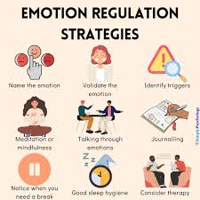  All About Me  Managing emotions | 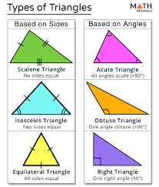    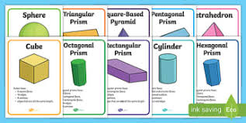  N umeracy/Maths  Shape - properties |     Literacy  Spelling, handwriting, reading and being a poet
      Physical Education  Fitness, Tennis, Rugby and Team building |   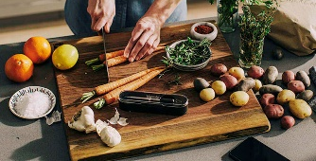  Life Skills  Cooking and Using IT |     Topic  Looking Up– Evolution of Flight

You can support this learning at home by:

- Speaking to your child about their learning.
- Encourage reading at home.
- Encourage your child to talk about their different feelings at home and how they could manage these in a positive way.
- Share with the school / teacher the good learning and activities that your child takes part in outside school so that we can celebrate these with them.

Our Day
A usual day at Rowanfield in Hawthorn consists of:

Mornings: predicable and consistent routines. We join together as a team to sit and enjoy breakfast with the children. We feel that this gives them a soft landing to start the day and a chance to chat to friends and the staff and practice those all-important social skills.

After breakfast we go to our own classrooms and focus on literacy and numeracy lessons with a break in between and opportunities to mingle with their Hawthorn peers.

Play Break outside in Hawthorn playground with opportunities to play with peers, use the climbing apparatus, use bikes and scooters.

Lunch: developing our social skills as we enjoy time to eat together.

Lunch Break outside in Hawthorn playground with opportunities to play with peers, use the climbing apparatus, use bikes and scooters.

Afternoons: PE and mix of opportunities for cooking, outdoor learning, science and IT.

Our Team in Hawthorn:
Class A: Mr Tyrrell (teacher), Mrs Mothersole (PSW)
Class B: Mr Slaven (teacher), Miss Gorrie and Miss Coxon (PSWs)
Class C: Ms Porter (teacher), Miss Philips (PSW)
Miss Ryder and Mr Lomax (PSOs)

School Clothes:
Pupils in Hawthorn learn outside in all kinds of weather so please send your child in with suitable clothing e.g. a warm coat if possible. We have lots of spares at school so if you would prefer us to use these please let us know.
We do PE Monday to Thursday. We do not get changed for PE.
We aim to explore the learning opportunities that living in Edinburgh has to offer and regularly plan trips further afield.
Please remember to sign the permission forms that we send home and return them to school.
Please label clothes and shoes with your child’s name

