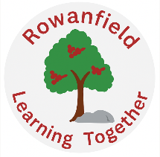
Willow Learning Leaflet
January to March 2026
Welcome to our Willow learning leaflet which lets you know what your child has been learning so far this term and what’s still to come. This term we are learning about…
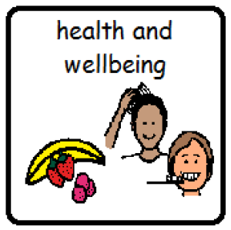  Health & Wellbeing  Relationships  My body | 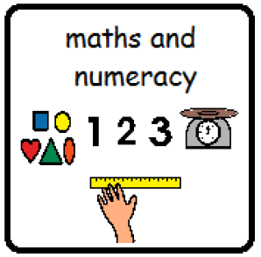  Maths  Number  Shape & Data | 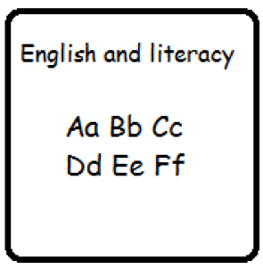  Literacy  Spelling, reading and writing
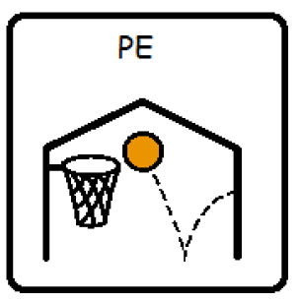  Physical Education  Hockey, Rugby, Dodgeball and Team building | 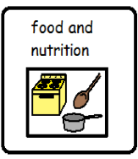  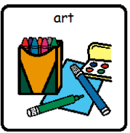  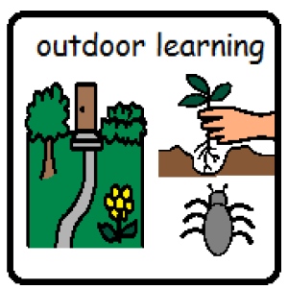  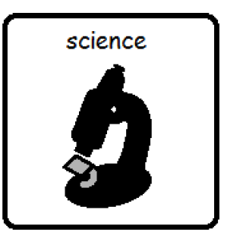  cooking  Activity Groups  Cooking, art, science and outdoor learning | 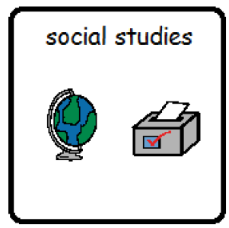  Social Studies (topic)  Looking Up - Space
You can support this learning at home by:
- Reading together.
- Pointing out numbers and words in everyday life.
- Look around the house for shapes and count how many you can find, practice saying the shape names.
- SumDog (online maths games) – if your child would like to access SumDog at home we can send their login details to you.
- Cooking a meal at home together.
- Please share any positive news from home so this can be celebrated in school too.

Our Day
A usual day at Rowanfield in the Willow team consists of:

Mornings: We start each day with breakfast and a soft start. Throughout the morning, we have PE, numeracy, literacy and soft play.

Afternoons: On Monday we sometimes leave school for a trip. The rest of the week we join as a team for activity groups. This provides the opportunity for children to mix with peers from other classes. Activities include art, outdoor learning, science and cooking.
This term we have visiting specialists from both Drake Music and Edinburgh Dance Academy who are providing additional opportunities for children to engage in expressive arts.

Class trip: All classes will have the opportunity to participate in trips every few weeks. This may include visits to the local library, play parks and country parks.

Our Team in Willow:
- Miss McGinty (teacher), Miss Gorrie (PSW)
- Mr Hawney (teacher), Miss Taylor (PSW)
- Mr Williams (teacher), Miss Costes (PSW),
- Mr Gordon (PSO) and Mrs Robertson (PSO)
- Miss Mozg (PSW), DD (PSW)

School Clothes:
Pupils in Willow learn outside in all kinds of weather so please send your child in with suitable clothing e.g. a warm coat if possible. We have spare clothes at school so if you would prefer us to use these please let us know. Please label clothes and shoes with your child’s name.

Reminders:
- We ask that your child does not bring anything from home such as toys, as this can cause upset with other pupils and we can’t guarantee that these items won’t go missing.
- Throughout the day there are opportunities to eat at breakfast, morning snack, lunch and afternoon snack. Your child is welcome to bring their own morning snack. We do provide fruit and milk for everyone at snack time.

courage, curiosity, compassion and creativity

