Sycamore Learning Leaflet
January 2026
We are learning about…
  Our local area |   The City |   The Seaside
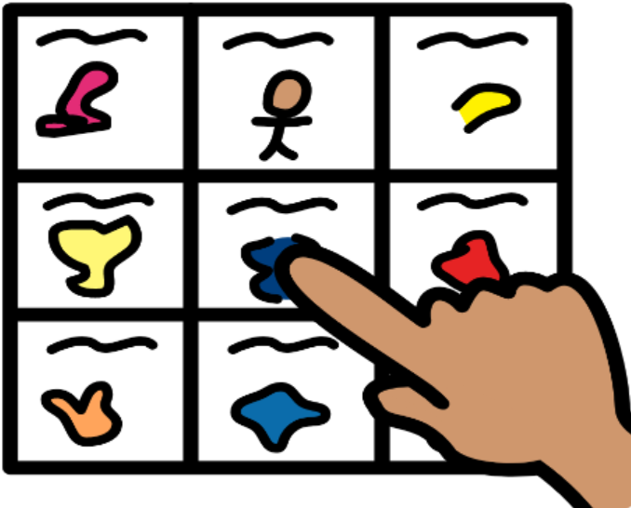  Communication Skills |   Life Skills | 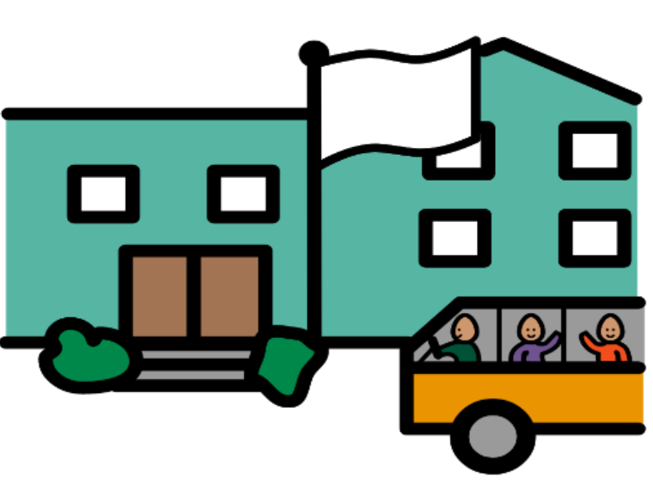  Moving On

You can support this learning at home by:
- Investigate things around you; What can you see, hear, feel, smell or taste?
- Practice getting ready for school independently – putting on shoes, changing clothes, brushing hair and teeth or making your own breakfast.
- Go on a bus journey to see the sites of Edinburgh or go for a walk in your local area
- Share core words and practice making choices*
- Share photos of your new teacher or your new school
*Staff in Sycamore work closely with Speech and Language therapy. Please let us know if any symbols are needed to support communication at home.
Our Team

Teachers
The Owls - Sarah Douglas
The Hedgehogs - Sarah McVie
The Squirrels - Lindsay Thomson
Sycamore Cover - Hannah Renwick

Pupil Support Officers
Lesley-Ann and Conor

Pupil Support Workers
Ashley, Lindsay, Leona, Lauren, Clara

Our Day
We start every day with Ready Steady Go. This is time to get ourselves ready to start the school day. We play outside, eat breakfast and say hello to our friends. The teachers check home-school books and we put away our coats and bags.

We come together as a class for lessons including Morning Meeting, Literacy and Numeracy. We sometimes visit Soft Play, the Rainbow Room and the library. We often work in small groups or 1:1 with an adult. We do PE Monday-Thursday and getting changed for this is a good opportunity for us to develop life skills.

Snack and Lunch give us the opportunity to try new foods and practice making choices. We use core words such as ‘more’ or ‘finished’. We are learning to sit at the table as a group and to share food appropriately.

Play is an important part of our day. We make links about the world around us as well as developing life skills. Play helps us develop our sense of self and find our voice. We spend time outside in the playground and going for walks.

School Clothes
Pupils in Sycamore learn outside in all kinds of weather so please send in full waterproofs (including wellies) a warm coat and if possible, a spare pair of play shoes. We have lots of spares at school so if you would prefer us to use these please let us know.
We do PE Monday to Thursday and practice getting changed every day. Each child should have a pair of shorts and a T-Shirt which will be kept in school and washed as needed.
As play can sometimes be messy we also ask that each child has at least one full change of clothes to be kept in school.
Personal care supplies for the week (nappies and wipes) should be sent in each Monday.
All clothes must be labelled

